**Tutorial 9**

**ECSE104L**

**Flip Flop conversion**

**D to JK flip flop**

Excitation table of D flip flop Characteristic table of J-K flip flop

|  |  |  |
| --- | --- | --- |
| **Qt** | **Q(t+1)** | **D** |
| 0 | 0 | 0 |
| 0 | 1 | 1 |
| 1 | 0 | 0 |
| 1 | 1 | 1 |

|  |  |  |  |  |
| --- | --- | --- | --- | --- |
| **Qt** | **J** | **K** | **Q(t+1)** | **D** |
| 0 | 0 | 0 | 0 | 0 |
| 0 | 0 | 1 | 0 | 0 |
| 0 | 1 | 0 | 1 | 1 |
| 0 | 1 | 1 | 1 | 1 |
| 1 | 0 | 0 | 1 | 1 |
| 1 | 0 | 1 | 0 | 0 |
| 1 | 1 | 0 | 1 | 1 |
| 1 | 1 | 1 | 0 | 0 |

Then using K map where inputs are Qt, J, K and output D we will find Boolean equation for D.

D = Qt’ J + QtK’

Then we draw the circuit.

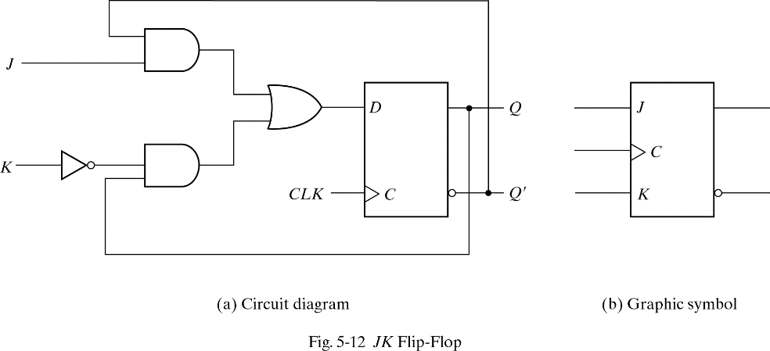

Question 1- Convert SR to JK flip flop

Question 2- Design T flip flop using D flip flop.

Question 2- Design the circuit for following state table table using D flip flop

|  |  |  |  |  |  |
| --- | --- | --- | --- | --- | --- |
| **Qt(A)** | Qt(B) | **Q(t+1)(A)** | **Q(t+1)(B)** | **D(A)** | **D(B)** |
| 0 | 0 | 1 | 0 |  |  |
| 0 | 1 | 1 | 1 |  |  |
| 1 | 0 | 0 | 0 |  |  |
| 1 | 1 | 0 | 1 |  |  |